UNE-EN 15343 Audit Program by Control Union WG Spain S.A. for the Certification of Traceability of Recycled Plastic.

PE CU TPR

Version 1.3
30.12.2024

Index
1. INTRODUCTION 3
2. OBJECT & CERTIFICATION SCOPE 4
3. REFERENCE STANDARDS 4
4. THERMS AND DEFINITIONS 5
5. CERTIFICATION TYPES 7
5.1 INITIAL CERTIFICATION 7
5.2 MONITORING CERTIFICATION 8
5.3 MULTISITE CERTIFICATION 8
5.4 PROVISIONAL CERTIFICATION 8
6. ELEGIBILITY FOR CERTIFICATION 8
7. OBJECT OF CONFORMITY 8
8. CERTIFICATION PROGRAMME MANAGEMENT 9
9. TRACEABILITY AUDIT PROCESS 9
9.1 APPLICATION 9
9.2 DOCUMENTATION REVIEW 9
9.3 AUDIT 10
9.4 REPORT 10
9.5 NON CONFORMITIES 10
9.6 CERTIFICATE EMISSION 10
9.7 EXAMPLES OF USE OF BRAND 11
10. CHANGES THAT AFFECT TO CERTIFICATION 11
11. ECONOMIC TOPICS 12
12. CHANGES CONTROL 12

1. INTRODUCTION
The UNE 15343 Traceability of Recycled Plastic Audit Program certification was developed by Control Union to help the plastics industry demonstrate and guarantee the application of circular economy principles.
Growing environmental awareness in our society is fostering consumer demand not only for high-quality products, but also for products produced in an environmentally responsible manner and with the sustainable use of natural resources.
In response to this reality, Control Union has launched a certification scheme designed to promote and guarantee the sector's transition toward a Circular Economy. This approach focuses specifically on completing the production cycle, transforming plastic waste into new resources.
Our certifications comprehensively cover the traceability of recycled material, from the reception of the plastic waste, through its processing, to its reintroduction into the market as recycled material. This includes the characterization of said recycled material, its conversion into pellets for subsequent use, and, finally, the certification of the percentage of this recycled material incorporated into new products.

2. CERTIFICATION OBJECT & SCOPE
The objective of this certification is to recognize the use of recycled plastics in products throughout the plastics value chain. The certification focuses on the traceability of recycled plastics within a process and the verification of the recycled content quotas (pre-/post-consumer) of plastic products or product families. Certified products and processes may use recycled content claims in accordance with the "REGULATIONS FOR THE USE OF CERTIFICATION MARK."
Material traceability at the various process steps must be verified throughout the entire chain of custody of the material in order to make a recycled content claim on the final products. Therefore, the certification can be granted individually to different companies participating in the value chain and responsible for safeguarding recycled plastics, including, but not limited to, compounders, converters, blowers, fillers, etc. The Scheme is developed in accordance with EN 15343:2007 and the principles of a controlled commingling chain of custody model as described in ISO 22095:2020.

3. REFERENCE STANDARDS
EN 15342 Recycled plastics. Characterization of recycled polystyrene (PS)
EN 15343 Plastics. Recycled plastics. Traceability and conformity assessment of recycled plastics and recycled content.
EN 15344 Recycled plastics. Characterization of recycled polyethylene (PE)
EN 15345 Recycled plastics. Characterization of recycled polypropylene (PP)
EN 15346 Recycled plastics. Characterization of recycled poly(vinyl chloride) (PVC)
EN 15347 Recycled plastics. Characterization of plastic waste.
EN 15348 Recycled plastics. Characterization of recycled poly(ethylene terephthalate) (PET)
EN 15353:2006 Plastics — Recycled plastics — Guidelines for the development of standards for recycled plastics
EN ISO 14021 Ecolabels and environmental declarations. Environmental self-declarations (Type II ecolabel).
EN 17615 Plastics – Environmental Aspects – Vocabulary
ISO 22095:2020 Chain of custody – General terminology and templates
ISO 9001 Quality management systems. Requirements

4. TERMINOS Y DEFINICIONES

Applicant
Organization requesting Certification for a Process and Product(s), Component(s), or Family(ies) of Products.

Organization
[ISO 22095:2020, 3.4.1]
An entity or group of persons and facilities with an arrangement of responsibilities, authorities, relationships, and identifiable objectives.

Site
[ISO 22095:2020]
A geographically bounded location in which defined activities are carried out under the control of an organization.

Certification
Certification under this Audit Scheme.

Supplier
Company that provides Recycled Input, Product(s), Product Family(s) or Components.

Supplier’s certificate
Traceability Certificate for Recycled Plastics under a Certification recognized by Control Union WG Spain SA.

Product Code
Unique transaction code for an incoming batch of material.

Traceabiltiy
[ISO 22095:2020, 3.6.1]

140 / 5,000
Ability to trace the history, application, location, or source(s) of a material or product throughout the supply chain.

Batch
[EN/ISO 472:2013, 2.1679]
A quantity of material considered as a single unit and having a unique reference. Batch is primarily a processing term.

Recycled Input
Batches of certified recycled plastics identifiable with a unique transaction code. Certification must be granted by Control Union or a Control Union-recognized scheme based on UNE EN 14353:2007.

Uncontrolled recycled input
Batches of recicled material proceeding from a non certified supplier and/or without traceability.

Output
Plastic Products that come out of the Process for which Certification is being requested.

Plastic
Material consisting of a polymer as defined in Article 3, point 5, of Regulation (EC) No 1907/2006, to which additives or other substances may have been added, and which can function as a principal structural component of final products, with the exception of natural polymers which have not been chemically modified.

Product
Material, object or semi-finished product made wholly or partially from recycled plastics.

Family of products
Group of products manufactured using the same processing technology, within the same line, with a similar formulation, for similar applications, and containing materials from the same waste source.

Component
Specific elements of the output product when it contains different parts made of plastic, other materials or others.

Recycled Plastic
[EN/ISO 472:2013, 2.612]
Plastic prepared by processing in a production process from plastic waste materials for the original or other purposes, but excluding energy recovery. In a broad sense, plastics recycling covers any reuse of waste material or discarded items, including pyrolysis to recover useful organic chemicals. Recycled plastics may or may not be reformulated by the addition of fillers, plasticizers, stabilizers, pigments, etc.

Recycled Content
[CEN/TR 15353:2004, adaptado]
Percentage by weight of recycled plastics in a product. Percentage by weight of Certified Recycled Input at Output. Must be defined as Pre-consumer Material and Post-consumer Material.

Post-consumer Material
[ISO 14021:2016]
A descriptive term covering material generated by end-users of products that has served its intended purpose or is no longer usable (including material returned within the distribution chain). Note that the term "post-use" is sometimes used synonymously.

Pre-consumer Material
[ISO 14021:2016]
Descriptive term covering material diverted from the waste stream during a manufacturing process. Note that this term excludes reused material, such as rework, regrind, or scrap, generated in a given process and capable of being reclaimed within that same process. The term "post-industrial material" is sometimes used synonymously.

Waste, scrap, shredded material
[EN/ISO 472:2013, 2.1707]
Recovered plastic material, crushed and/or granulated in the form of free-flowing material. The term is frequently used to describe scrap plastic material generated in a plastics processing operation and reused internally. The term is also used to describe fine plastic powder used as filler in plastics recovery.

Waste
[EN/ISO 472:2013, 2.1710]
Any material or object that the possessor discards, intends to discard, or is required to discard.

Process
[ISO 22095:2020, 3.2.10]
A set of interrelated or interacting activities that use inputs to deliver an intended result.

Subcontracted Process
Recycled Entry delivered to the Site that is produced by a third-party company also certified under the Certification where the Applicant retains ownership of the Third-Party Organization's Result.

5. TYPES OF CERTIFICATION

5.1 INITIAL CERTIFICATION
Initial Certification must be performed at a site that must provide production records for the 12 months prior to the production process. This Certification is valid for one year.

5.2 MONITORING CERTIFICATION
La Recertificación debe realizarse en un Sitio que debe presentar registros de producción de los 12 meses anteriores al Proceso de Producción.
La Recertificación se otorgará al Sitio cuando esté disponible la Certificación del año anterior. Esta Certificación es válida por 1 año.

5.3 MULTISITE CERTIFICATION
La Certificación Multisitio debe emitirse cuando un proceso de producción se lleva a cabo en dos o más lugares separados bajo la misma propiedad del Sitio. El sitio deberá designar una ubicación como dirección principal y contacto para los fines de la Certificación. Ambas ubicaciones deben visitarse durante la auditoría, enumerarse en el informe, y se debe verificar la trazabilidad entre ambas ubicaciones. Esta Certificación es válida por 1 año.

5.4 PROVISIONAL CERTIFICATION
In case that audited company has less that 12 months of registers, but more than 3 months, and at least three batches of produced references, and accomplish with all other requirements, a provisional certificate can be provided, that will be replaced one year later for a normal certificate in the monitoring audit.

6. ELEGIBILIDAD PARA LA CERTIFICACIÓN
Any Plastic Product containing Recycled Plastics can apply for Certification. This includes compounds, semi-finished or finished products, or components that are ready for commercialization or are still under the control of the value chain and are sold from one company to another.

The audited processes include, but are not limited to, compounding, conversion, storage, marketing, or other activities within the plastics value chain.

7. OBJECT OF CONFORMITY
The certification enables all actors in the plastics value chain to demonstrate transparent use of recycled plastics in products. Conformity assessment focuses on the traceability of recycled plastics within a process and verification of the declaration of a certain percentage of recycled plastic content in products. The certification is available to all value chain actors involved in the use of recycled plastics and enables demonstration of compliance under Control Union's Traceability of Recycled Plastics audit scheme in line with the requirements of EN 15343:2007.

8. CERTIFICATION PROGRAMME MANAGEMENT
Control Union WG Spain S.A. will be responsible for planning, implementing, and managing the recycled plastics traceability certification process, covering the entire process from receipt of the certification application to the end of the process, including the issuance of the final evaluation report and certificate.

9. RECYCLED PLASTIC TRACEABILITY AUDIT

9.1 APPLICATION

When an organization contacts Control Union WG Spain SA to request certification, they are sent an application form to complete with the necessary information for each product and production facility they wish to request certification. This information is used to prepare a commercial proposal. Once the client accepts the offer, the audit date will be coordinated, and the audit plan will then be sent. This request will include information and documentation that the client must submit prior to the audit. The audit plan will also specify the visit date and the assigned audit team.

9.2 DOCUMENTATION REVIEW
Control Union WG Spain SA will review and analyze the documentation provided by the company.
The following Will be requested
- Supplier certification (Percentage of post-consumer plastic / percentage of total recycled plastic).
- - Product codes of the materials for which certification is required.
- - Calculations of the recycled material content incorporated into the products. The calculation methodology will be validated during the audit and could be used for possible extensions to the scope of the certification.
- - Technical data of the products within the scope of the certification (product specifications, bill of materials, formulation).

If necessary, some documentation may be reviewed during the on-site visit. Additional information may also be requested.

9.3 AUDIT
After conducting a document review, the Union Control Audit team will visit the production site and verify that the organization has implemented the necessary processes and steps to ensure that the recycled material incorporated actually comes from pre- and post-consumer sources. The control processes for recycled material and the certification of recycled content in the final product will be verified. To this end, the following will be verified:

- Organization shall hav controls over the recycled material incorporated into the process, recording the origin, type of recycled material (post-consumer or pre-consumer), provenance (supplier certificates), history of the recycled product (e.g., contact with known hazardous substances), tests performed by the recycler, UNE EN 15347 Characterization of recycled plastics from plastic waste or as appropriate for the final application.
- Production records.
- Traceability of recycled material from source to final product to confirm the percentage of recycled material. Exercises will be conducted.
- Formulas for manufactured products.
- Process control to ensure that recycled materials are dosed in the indicated proportion during production.
- Mass balance.
- Calibration certificates for measuring equipment.
- Technical data sheets for products with recycled material.

Control Union recognizes other certificates issued by independent certification bodies that have the corresponding accreditation for the certification of traceability of recycled plastic.

9.4 REPORT

The assessor will record the assessment results in a report, summarizing the conformity and detailing the nonconformity, including supporting evidence. The report will include the results along with all certification requirements.

9.5 NON-CONFORMITIES
If nonconformities are detected, the organization must submit a corrective action plan and evidence of correction and implementation within 12 weeks of the audit to the audit team for evaluation, approval, and remediation.

Control Union must inform the client of all nonconformities and observations.

The client must express their interest in continuing the certification process. In this case, Control Union will provide information on the additional assessment tasks required to verify that the nonconformities have been corrected.

9.6 CERTIFICATE EMISSION
Once all the necessary information is available, including the audit report and, if applicable, a corrective action plan, a technical review will be conducted, and a decision will be made to grant the Certification.

The issued Certificate will be valid for one year. The certificate's annex will indicate the type of recycled material audited, along with the respective percentage of pre-consumer or post-consumer certified recycled material used.

If it is decided not to grant certification, the reasons will be explained in detail.

9.7 EJEMPLOS DE USO DE MARCA
La Organización que ha recibido la Certificación podrá hacer uso de la marca como se muestra a continuación.
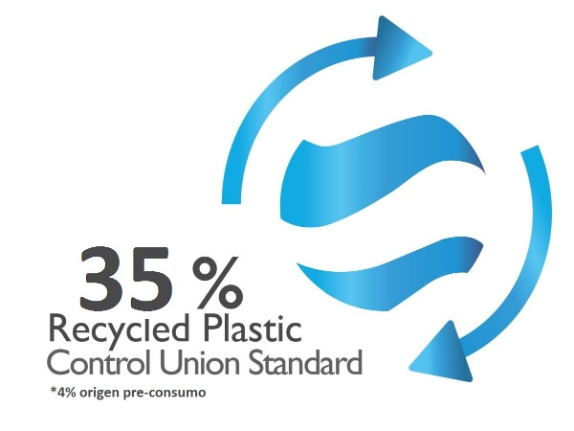
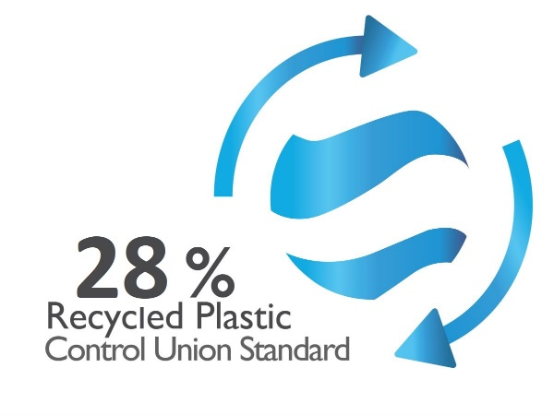

For further details, please refer to the Control Union Trademark Usage Regulations.

10. CHANGES THAT AFFECT TO CERTIFICATION
Changes to the product, process, or quality management system that would affect compliance with the Audit Scheme requirements must be communicated to Control Union so that the information can be reviewed and a decision can be made as to whether a site audit is necessary before amending the Certificate. If a site visit is necessary, its scope will be limited to certifying compliance with the requirements set out in section 9.3.

The scope of the visit will be limited to certification of the following requirements:

- Quality management system
- Control processes for recycled materials
- Certification of recycled material content in the final product

When the applicant wishes to extend the scope of the conformity assessment, add or remove products, or change the percentage of recycled content in a certified product, this must be communicated to Control Union in order to amend the Certificate. The changes will be indicated on the certificate without changing the validity period.

Extending the Certification to include new products or changing the percentage of recycled content will require Control Union to verify new recipes, product data sheets, and production records for the relevant production batches.

After technical review of the report with the results, Control Union will decide on the necessary changes to the certificate, which will be consistent with the current situation.

11. ECONOMIC TOPICS

CU WG Spain SA will determine and communicate to organizations requesting certification the financial conditions for the activities related to the granting, monitoring, and renewal of the Certificate in the service offer.

12. CHANGES CONTROL
Fecha | Versión | Resumen de Cambios
15.02.2023 | 1.0 | Creación de documento
02.02.2024 | 1.1 | Se añade la introducción
02.02.2024 | 1.1 | Se elimina la opción de Certificación Provisional del punto Tipos de Certificación.
02.02.2024 | 1.1 | Se mejora el texto en el punto 9.3 para hacer referencia a la necesidad de certificación acreditada como única opción.
02.02.2024 | 1.1 | Se eliminó la aceptación gradual del Certificado de Proveedores
02.02.2024 | 1.1 | Se mejoran los textos y se indican los puntos del 1 al 12
26.04.2024 | 1.2 | 9.1 Se aclara en el texto que se solicitarán los datos necesarios de cada producto y centro de producción que se desea pedir la certificación. También se indica que el plan de auditoría informa la fecha de visita y el equipo auditor asignado.
26.04.2024 | 1.2 | 9.2 Se mejora la redacción sobre los Cálculos de contenido de material reciclado.
26.04.2024 | 1.2 | 9.3 Se mejora la redacción indicando que la visita se realizará luego de la revisión documental y se describen con mayor detalle las comprobaciones que se realizarán durante la auditoría en sitio.
26.04.2024 | 1.2 | 9.6 Se completa el texto detallando que se indicará en el anexo del certificado el respectivo porcentaje preconsumo o posconsumo de material reciclado certificado utilizado.
26.04.2024 | 1.2 | 10 Se aclara que en caso de que la visita sea necesaria, el alcance de la misma quedará limitado a la certificación de los requisitos establecidos en el punto 9.3.
30-12-2024 | 1.3 | Se actualiza el plazo de 12 meses.

